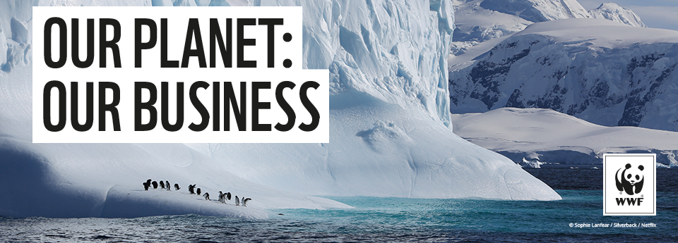

STUDENT WORKSHEET
Name:
Class:

Watch Our Planet: Our Business and complete the reflection activities below, your teacher will provide instructions on where and how to access the film. You can choose to complete these activities whilst you watch the film, pausing to reflect on the issues and questions raised, or at the end.
Our Planet: Our Business raises one of the most important challenges of our time: How can business help to tackle the world’s environmental crisis? Created for WWF by the Emmy Award-winning Silverback Films, Our Planet: Our Business shows the immense value of nature to our economy, the scale of the challenges that we are facing, and the critical role that business can play in creating solutions at scale. It shows what’s at stake if we continue with ‘business as usual’.

- Planet Earth has not always been habitable for life. Using the table below, make notes on how conditions on our planet have changed in order to support life:

Non-habitable Earth | Habitable Earth

- What defining characteristic of the Holocene period enabled humanity and other life on Earth to thrive? How did this benefit us? Make notes below.

- What does the term ‘The Great Acceleration’ refer to? Bullet point some key facts about this period below.

- Our planet has now entered a new age called The Anthropocene. What does the term The Anthropocene mean? Bullet point some key notes about this period below.

- Give examples of some of the ways mankind’s activities have affected our planet’s natural resources:

- “There’ll be no jobs on a dead planet” – Bren Smith.

Considering the issues that have been raised in Our Planet: Our Business, what do you think Smith meant when he said this?

- List below some of the effects we are already seeing on our planet as a result of increased global temperature:

- Scientists have predicted the changes to our planet that a baby born today might experience over their lifetime, if humanity does not act quickly. Note down a prediction made for each of the years below.

2040s:

2050s:

2080s:

2100s:

9. What are the five universal goals that business should be striving towards not only in their own organisation but in their investments and supply chains?

1.

2.

3.

4.

5.

10. How are the mindsets of consumers and entrepreneurs changing? What differences are there between how previous generations view business and how new generations are likely to view business?

11. Why will these changing mindsets drive businesses to change?

12. On Wednesday 17th June at 2pm, you will be attending an expert panel Q&A, organised by WWF-UK, based on Our Planet Our Business. Use the space below to brainstorm and jot down any questions, comments or concerns that this film has raised for you, and come ready to put these to the experts on June 17th !

WHAT NEXT?
- Write a letter to a local politician or business and tell them about an environmental issue that is close to your heart. And don’t be afraid to ask questions!

- Help scientists to record the variety of wildlife in your area by taking part in a citizen science programme. Create habitats for wildlife in your own backyard (e.g. a bug hotel, rotten logs for beetles, heaps of branches and leaves for hedgehogs) and grow plants to attract bees, butterflies and other pollinators.

- Use less plastic, reuse and recycle. Try to buy things that last for a long time and can be repaired or recycled. Things like bicycles and clothes can be mended.

- Speak out! Talk about the importance of protecting nature with your friends, families and teachers.

- Start a movement in your school or community to help the planet by planting trees or saving energy. Remember, schools are businesses too – what changes could you campaign for to make a difference?

- Think about the food you eat. The ways in which we grow and produce our food has a massive impact on the planet. Eating more plant food helps! Producing 1kg of beef requires 70 times as much land as producing 1kg of vegetables.

EVEN SMALL CHANGES CAN ADD UP TO BIG ACTIONS

