‘A climate of possibility: Harnessing Scotland’s Natural resources to end our contribution to climate change’
23rd January 2019

Summary
This project adapts research developed for WWF UK, to conduct a bottom up study to show how fast Scotland can meet net zero emissions (by 2050 at the latest) with domestic action. The objective of this work is to provide insight into what achieving net zero greenhouse gas (GHG) emissions implies for Scotland. It builds on the following key evidence sources:

- CCC advice to Scottish Government
- Academic work on greenhouse gas removal (GGR) potential in Scotland
- UK scenario for net zero emissions, based on previous Vivid analysis for WWF to illustrate UK-wide net zero pathways

Reducing Scotland’s net emissions to zero will end our contribution to climate change, help to restore nature and build an innovative, globally-facing economy. We have long known that the economic costs of tackling climate change far outweigh the costs of failing to act and that the benefits for human health, the economy and nature are huge. Reaching for net zero and planning a just transition towards it will allow us to build a healthier, cleaner, flourishing Scotland for all, and strong working relationships with other nations striving for a living planet.

KEY messages
- Maximising Scotland’s assets: Scotland is well positioned to reduce its emissions given its natural endowments and potential for carbon sinks.
- Sectoral reductions needed: To reach net zero, deep emissions reductions are necessary across all sectors but not all sectors will themselves reach zero emissions.
- Greenhouse gas removal (GGR) key: A portfolio approach to GGR would allow Scotland to set a robust pathway towards achieving negative emissions by 2050.
- Multiple pathways: There are multiple options for Scotland to deliver and exceed net zero by 2050, even with weaker than expected GGR deployment.
- Net zero before 2050 is feasible: Scotland reaches net zero GHG emissions before 2045 in our scenario, with options to further reduce emissions. This could even happen sooner with further action, for example on sinks or dietary change. And by 2050, Scotland could be removing far more emissions than it creates (-120% on 1990).

Opportunities for further emission reductions
Scotland’s current emission reduction pathway implies deep emission cuts across all sectors.

As set out by the CCC, Scotland must drastically reduce emissions across all economic sectors. This implies deep cuts across all sectors, with approximately 34 MtCO₂e reduced from 2016 levels and 60 MtCO₂ from 1990 levels. It is achievable while maintaining economic growth, and without reducing production of carbon intensive products. However, a broad suite of supportive policy from Scottish Government will be required, to incentivise the required transition and mitigate carbon leakage risk.

- The power sector, transport and buildings sectors can all reach zero or near-zero emissions.
- Emissions in industry can be reduced by at least 60% without reducing productive capacity.
- Agriculture can reduce emissions by around 35% while maintaining current production levels. Farms will have a growing and crucial role in deploying carbon sinks to help offset emissions, with each farm on average deploying some form of GGR, often alongside existing practices.
- Carbon sinks have a critical role to play in balancing remaining emissions and can even take us beyond net zero to -120% emissions reduction by 2050 with enough policy support and a strategic approach.

GGR Deployment and implications for scotland’s land use
Achieving large scale GGR in Scotland by 2050 will require a rapid ramp up over the coming decades. This will require strong policy support from both the Scottish and UK governments.
Deploying currently known emission reduction measures across its economy, Scotland would emit around 13 MtCO₂e per year in 2050 (Figure 1).
Figure 1: Scotland’s Emissions in 2050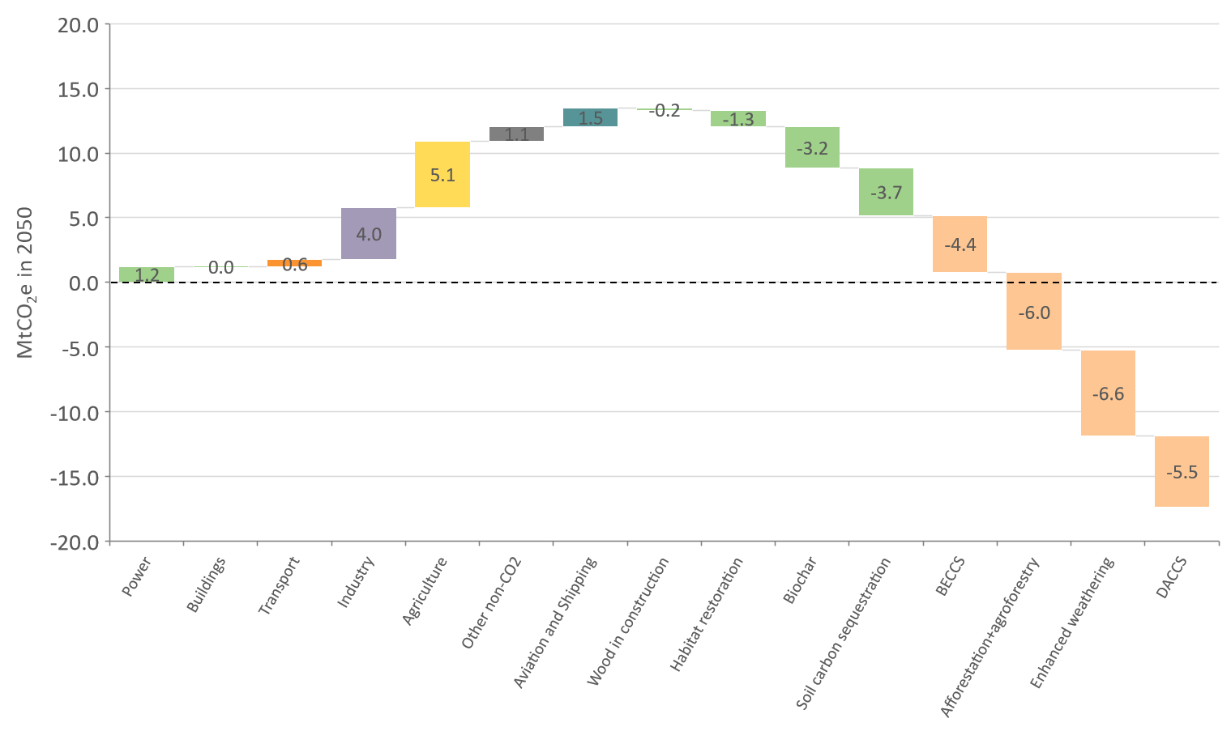
Source: Vivid Economics calculations, based on Alcade et al. (2018), CCC (2017), Vivid Economics (2018)
Given Scotland’s large land area, it can compensate for these emissions through a portfolio of GGR options. A portfolio approach to GGR – pursuing mature options and testing less-mature options - would allow Scotland to set a robust pathway towards achieving negative emissions by 2050.
Our scenario (see Appendix 1) sets out a portfolio of GGR options deployed at scale, which together achieve -31 MtCO₂ of GGR in Scotland. GGR deployment in Scotland could exceed the -31 MtCO₂ included in our scenario. This scenario makes two key judgements:
- Land use change: Our scenario has been constructed to limit the impact on current Scottish land use patterns, and reflects a preference towards nature-based solutions.
- DACCS deployment: We include a modest deployment level given DACCS technological immaturity and related uncertainty. However, Scotland’s large renewable capacity and availability of CO2 storage could allow it to deploy DACCS significantly beyond the level included in our scenario.

Policy alignment to maximise GGR potential:

- Helping landowners/farmers deliver ‘public good’: Incentivisation is key to ensure the deployment of land use change including biochar, enhanced weathering, soil carbon sequestration and agroforestry, alongside existing food production.
- Reinvigorating the Scottish Land Use Strategy: GGR deployment will require a national approach to ensure land use implications are coherently managed. With full political support and effective regional delivery, the existing Land Use Strategy could provide a mechanism to deliver strategic and integrated land use and management change required to maximise GGR.
- Coordinating infrastructure planning and construction: This is particularly relevant for BECCS and DACCS, which require CO₂ transport and storage infrastructure. The required infrastructure should be coordinated across BECCS, gas generation with CCS, and industrial CCS to maximise infrastructure utilisation and minimise costs.

Contact | Lyndsey Croal, Public Affairs Manager, WWF Scotland
Email/Tel | lcroal@wwfscotland.org.uk 0131 659 9019
Date | 22 January 2019
1961-2013: Over 50 years of conservation. WWF works in over a hundred countries to safeguard the natural world so that people and nature thrive.

Appendix 1
Box 1. Land use implications of large scale GGR in Scotland
- Scotland currently uses 5.6 Mha for agriculture. By 2050, BECCS and biochar will require a combined 0.2-0.4 Mha, and afforestation will require around 0.5 Mha.
- Scotland has 0.2 Mha of land marginally suited for short rotation coppice (SCP) which can be used for GGR (Alcade et al., 2018). Furthermore, agroforestry could reduce the land requirement for afforestation up to 0.1 Mha, minimising competition with agriculture (CCC, 2018a).
- Overall agricultural production can increase despite GGR deployment, as agricultural productivity improvements from the wider agricultural strategy (National Farmers Union Scotland, 2018) and associated with some GGR practises (The Royal Society & Royal Academy of Engineering, 2018) are expected to outweigh reductions in agricultural land (CCC, 2018a).
GGR | Total land required (Mha) | Annual MtCO₂ abated | Notes
BECCS | - 0.2 | 4.4 | All biomass for BECCS in Scotland is sourced from Scotland.
Biochar | 0.1-0.2 | 3.2 | All biochar is sourced from Scotland.
Afforestation | 0.4-0.5 | 6.0 | This assumes planting rate of 16,000 ha/a as per CCC (2017). Agroforestry could reduce required planting rates (of forests) by around 2,000-3000 ha/a.

